Product data from eBay example https://www.ebay.com/itm/127001117718
Fields and photo’s that can be extracted
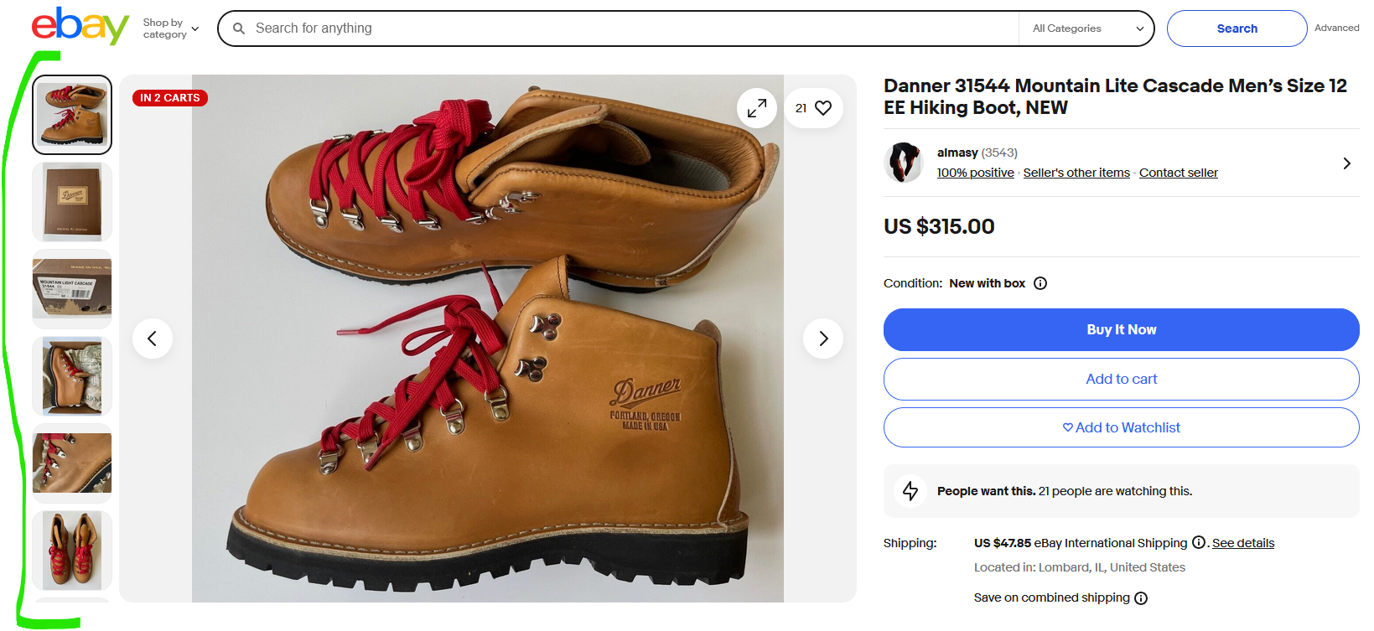
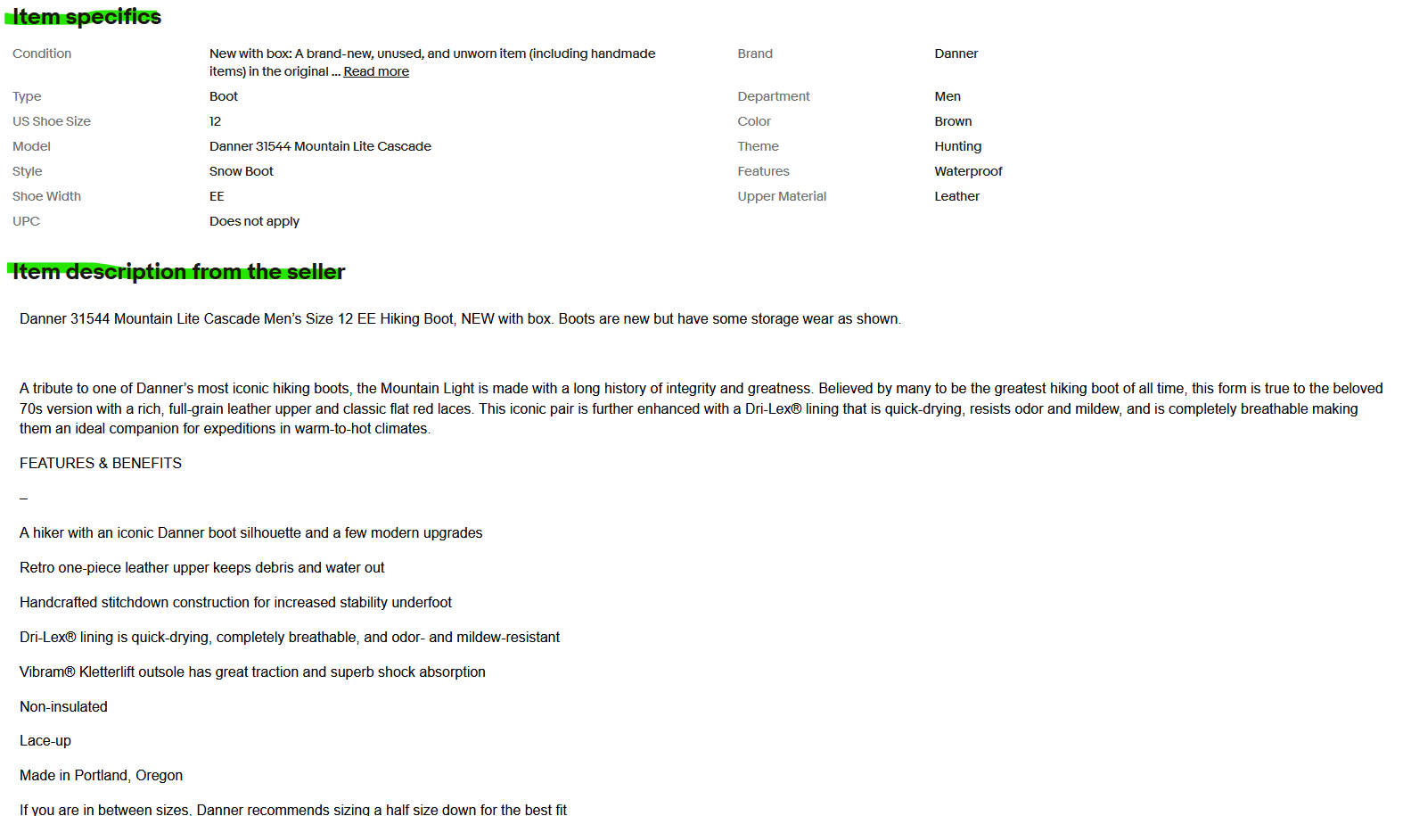

How to export eBay data:
To export eBay data, navigate to the "Reports" tab in your Seller Hub and choose the "Download" option. Select the source (Orders or Listings) and the type of report you want to download, then specify the date range (if applicable). Finally, click "Download" to get your data in a CSV file.
Here's a more detailed breakdown:
1. Accessing the Reports:
- Go to your eBay Seller Hub and click on the "Reports" tab.
- From the left-hand menu, select "Download".
2. Choosing Your Data Source:
- Select either "Orders" or "Listings" as the source of your report.
- If you want to download your order history, select "Orders". If you want to export information about your active listings, select "Listings".
3. Selecting the Report Type:
- Choose the specific type of report you need. For example, if you selected "Listings", you might choose "All active listings", "Unsold items", or "Edit price and quantity".
4. Defining the Date Range (if needed):
- If you are downloading orders or specific types of listings, you can specify a date range to narrow down the data you are exporting.
5. Downloading the Data:
- Once you've selected the source, type, and date range, click the "Download" button to get your data in a CSV file.
6. Using the CSV File:
- You can open the CSV file in a spreadsheet program like Microsoft Excel or Google Sheets to view and manipulate the data.

