Product data from Walmart example https://www.walmart.com/ip/Serengeti-Odell-SS555002-Sunglasses-Matte-Khaki-Saturn-Polarized-Drivers/1489216179
Fields and photo’s that can be extracted
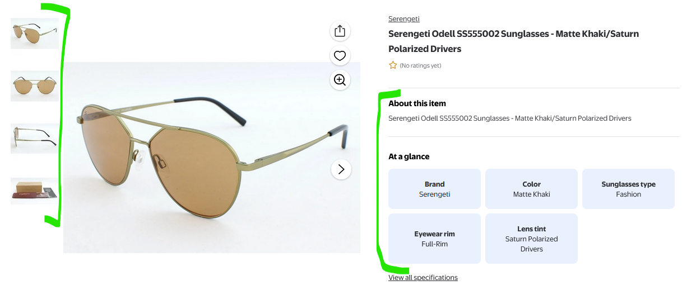
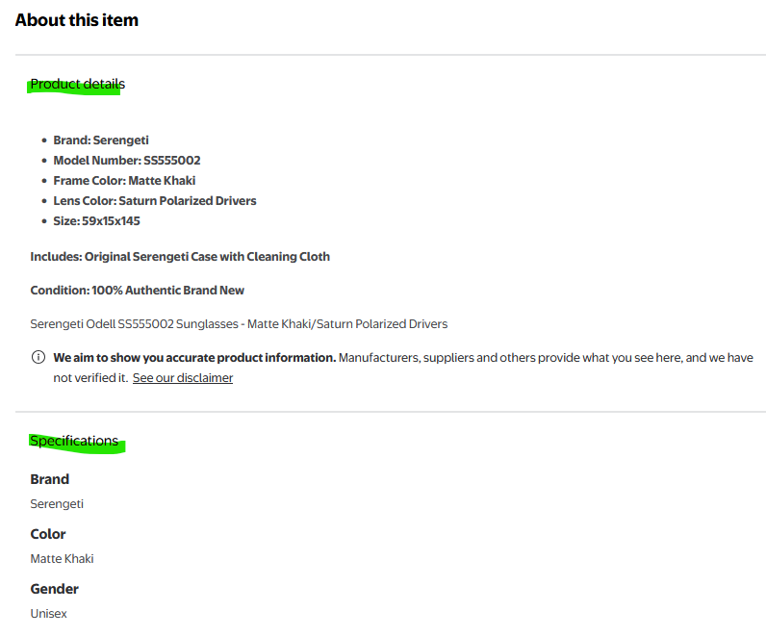

How to export Walmart data:
For Marketplace Sellers:
If you sell on the Walmart Marketplace, you can access sales data and reports through the Seller Center. Specifically, you can find payment history and download summary reports to view your sales data.
For Catalog Data:
If you're working with the Walmart Catalog, you can export data in spreadsheets. You can select pre-defined attributes, customize your download, or download editable spreadsheets for specific categories like DSV Inventory or Product Content & Site Experience.

