Product data from Amazon example https://www.amazon.ca/Serengeti-Modugno-Pilot-Sunglasses-Mineral/dp/B0C3YLZFDQ
By providing us with a list of the ASIN ID’s we can extract all of the fields from the Amazon listing page including the photo’s. This data can be used for your own website or for scouting your competition.
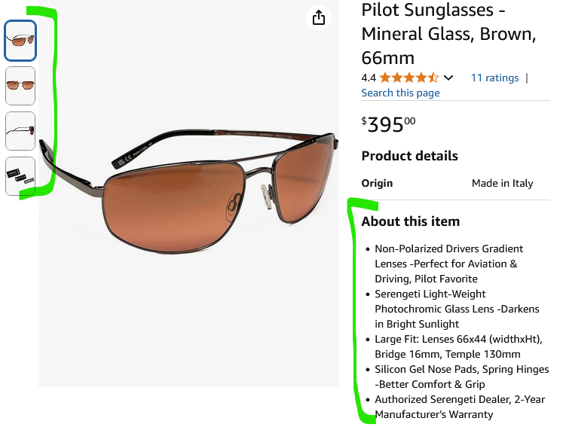
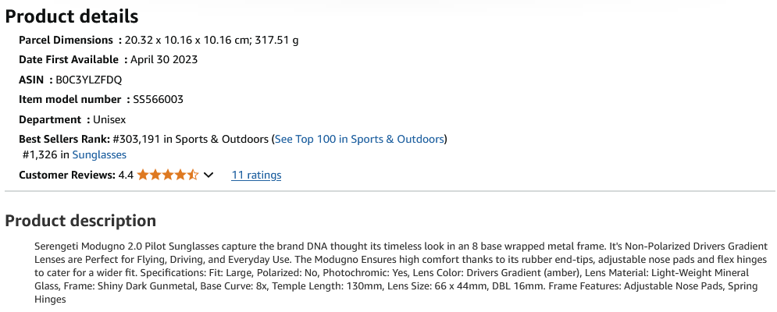
How to export Amazon data:
- Log into Amazon Seller Central: Go to sellercentral.amazon.com and sign in with your credentials.
- Go to Inventory Reports: Click on the Menu button, hover over "Inventory", and select "Inventory Reports".
- Select the Report Type: Choose the report type you need. Common options include "All Listings Reports" (for all your listings, active or inactive) or "Active Listings Reports".
- Request the Report: Click the "Request Report" button.
- Download the Report: The report generation may take some time. Once it's ready (status "Ready"), click the Download button to save it to your computer. The file is typically in a text (tab-delimited) format.
- Optional: Customize the report: You can customize the columns included in the report before requesting it.

